LAB 01 – CLASSROOM EDITION: THE CIPHER JOURNEY
Topic: Classical Cryptography (Caesar, Vigenère, Substitution) & Security Principles.
Goal: Explore historic encryption tools, understand their weaknesses, and reflect on real-world security principles.
Total Points: 100
Tools Required: FrequencyAnalyzer.html, tools/AvalancheAES.html
Attention: You are required to capture screenshots during the lab. Failure to provide the required screenshots may result in the loss of all assigned points for the corresponding step.

Step 1: The Roman Messenger (Caesar Cipher) (10 Points)
Access the Crypto Analyzer Suite here for the lab
Story Context:
You are a messenger for Caesar carrying a message through enemy territory. The enemy can read Latin, so you must Shift the letters. If captured, you must NOT reveal the key (Shift Amount), even if they bribe you. Your Key is determined by your "Legion ID" (Student ID).
Visual Concept:
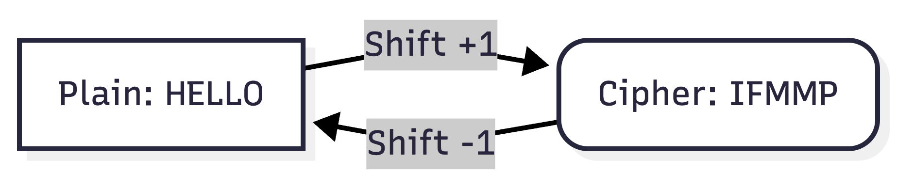

1.1 Identity Parameters
- Plaintext: [YourFullName] is learning security
- Key (Shift): Last Digit of your Student ID (If 0, use 10).

1.2 The Encryption
- Open FrequencyAnalyzer.html -> Tab "Caesar".
- Enter your Plaintext and Shift.
- Record the Ciphertext.
Screenshots are required to be taken as part of the submission. The required screenshots include the following:
- Caesar Setup: Screenshot of the tool with your input/output (Red box around Shift).
- Caesar Frequency: Screenshot of frequency chart (Green arrow to most frequent letter)

Step 2: The Diplomatic Cable (Vigenère Cipher) (10 Points)
Story Context:
You are a Diplomat sending a cable to HQ. The simple Caesar Shift was broken last week. HQ issued a "Code Book" (Keyword). You must add the keyword to your message to scramble the frequencies.
Visual Concept:
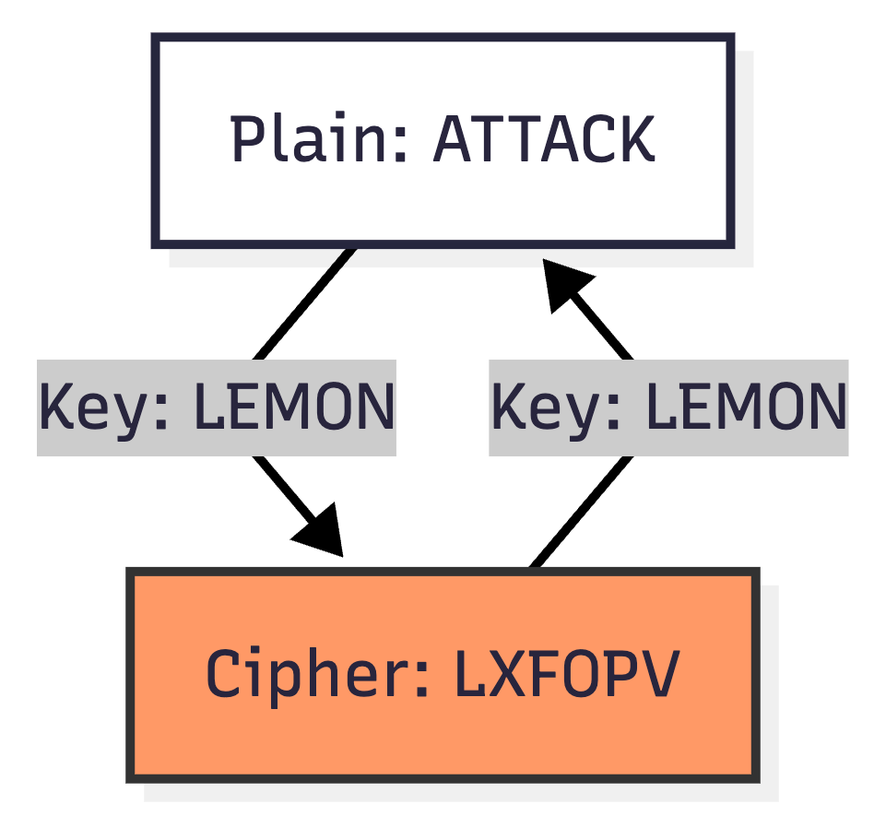

2.1 Identity Parameters
- Plaintext: [YourFullName] is learning security
- Keyword: Your First Name.

2.2 The Encryption
- Open FrequencyAnalyzer.html -> Tab "Vigenère".
- Enter Plaintext and Keyword.
- Record the Ciphertext.
Screenshots are required to be taken as part of the submission. The required screenshots include the following:
- Vigenère Setup: Screenshot of the tool (Red box around Keyword).
- Vigenère Frequency: Screenshot of frequency chart showing "flatness".

Step 3: The Zodiac Puzzle (Substitution Cipher) (10 Points)
Story Context:
You are a Detective solving a serial killer's puzzle. He didn't just shift the alphabet; he mixed it up completely. A -> Q, B -> F, etc. This creates a massive number of possibilities.

3.1 Identity Parameters
- Plaintext: [YourFullName] is learning security
- Key (Alphabet): A scrambled alphabet starting with your initials. (e.g., AB...).

3.2 The Encryption
- Open FrequencyAnalyzer.html -> Tab "Substitution".
- Enter Plaintext.
- Generate a Random Key (or type one).
- Record the Ciphertext.
Screenshots are required to be taken as part of the submission. The required screenshots include the following:
- Substitution Setup: Screenshot of the tool (Red box around Key).
- Substitution Frequency: Screenshot of frequency chart showing peaks.

Step 4: The Butterfly Effect (Avalanche Effect) (30 Points)
Access the encryption visualization tool here for the lab
Story Context:
Modern encryption (like AES) relies on a property called the Avalanche Effect. A small change in the input (like flipping 1 bit) should cause a drastic change in the output. Conversely, if a single bit of ciphertext is corrupted, the decryption should fail catastrophically (or produce garbage), preventing attackers from making controlled modifications.

4.1 Identity Parameters
- Plaintext: [YourFullName] is testing AES
- Key: [YourStudentID]Secret

4.2 The Experiment
- Open tools/AvalancheAES.html.
- Select Mode: AES-CBC.
- Enter your Key and Plaintext. Click Encrypt.
- In the Insecure Channel (middle), click on ONE single bit to flip it (red).
- Click Decrypt.
- Observe the Decrypted Message (M') and the status message.
  - Note: If you see a "Padding Error", this is normal! It means the avalanche effect was so strong it destroyed the message structure.
- Take a screenshot showing the flipped bit and the result (Garbage or Error).
Screenshots are required to be taken as part of the submission. The required screenshots include the following:
- Avalanche Effect: Screenshot of the AvalancheAES tool showing the scrambled output after flipping a bit.

Step 5: Analysis & Reflection (40 Points)

5.1 Keyspace Analysis (15 / 40 Points)
Caesar:
1. The Frequency Analyzer tool seen in the lab is used to determine the number of times a letter appears in a message. As a passive observer, Eve, how can the frequency of letters and other patterns in a ciphertext help compromise the confidentiality of the message?
2. An attacker Mallory intercepts a communication between Alice and Bob that was encrypted using a Caesar Cipher. The message that Mallory can see is unreadable, but she is able to pretend to be Bob and send messages to Alice. How can Mallory use messages to break IND-CPA security and decipher the message? Would Mallory be able to recover the key used in the Caesar Cipher?
Vigenère:
1. Encrypt a message of your choice using both the Caeser and Vigenère ciphers. Use a message of substantial length (copy a paragraph from the syllabus or other sources). Paste both ciphertext messages into the frequency analyzer one at a time and observe the results. Which cipher do you believe provides better resistance to brute force attacks and why?
2. Encrypt the same message used above with a different Vigenère key and observe the ciphertext of both encryptions. Describe how changing the key affects the structure and appearance of the ciphertext. Would a passive observer, Eve, be able to determine any information with these ciphertexts that could break IND-CPA security.

5.2 Avalanche Analysis (15 / 40 Points)
- Observation: In Step 4, when you flipped just one bit of the ciphertext, describe what happened to the decrypted message. How many characters in the decrypted message were changed?
- Reflection: Why is the "Avalanche Effect" desirable in encryption? Describe how encryption becomes less secure when small changes to the ciphertext like modifying single bits does not cause an Avalanche Effect. How could Mallory use small predictable changes to modify the contents of a message by only modifying the ciphertext.

5.3 Real-World Security Principles (10 / 40 Points)
- Enlist at least three security principles that you have encountered in real life. (e.g., Least Privilege, Defense in Depth, Separation of Duties, etc., and where you saw them). Just think of the real world, not the classroom, for example, a cafe has a barista and a cashier, the barista is responsible for making coffee and the cashier is responsible for taking orders, the barista should not be able to access the cashier's data and vice versa.

Step 6: Deliverables
Please be mindful of the submission naming convention. Failure to follow the required format will result in a 10-point penalty. The naming convention is straightforward, therefore, ensure it is followed correctly. This naming convention will be used for every assignment this semester.
Submission file format: FirstName_LastName_Lab01_Final.docx
Example: For a student named Tahmid Chowdhury, the correct file name would be
Tahmid_Chowdhury_Lab01_Final.docx
Please ensure that all of the following screenshots and corresponding answers are included in your submission. Failure to provide the required screenshots may result in the loss of all assigned points for the corresponding step.
- Caesar Setup: Screenshot of the tool with your input/output (Red box around Shift).
- Caesar Frequency: Screenshot of frequency chart (Green arrow to most frequent letter).
- Vigenère Setup: Screenshot of the tool (Red box around Keyword).
- Vigenère Frequency: Screenshot of frequency chart showing "flatness".
- Substitution Setup: Screenshot of the tool (Red box around Key).
- Substitution Frequency: Screenshot of frequency chart showing peaks.
- Avalanche Effect: Screenshot of the AvalancheAES tool showing the scrambled output after flipping a bit.
- Answers: Responses to the questions in Step 5.

References & Further Reading
Lab-wise, if you face any difficulties regarding the setup, tool usage, markup help, please feel free to reach out to the TAs during office hours or via email. All assessments and deductions are done at the discretion of the TAs, but mostly based off of a preset rubric to ensure fairness and consistency, if you have any reservations with how your submission was graded, please raise them within three days of receiving your points.
These are some resources that you can use to learn more about cryptography.
- Khan Academy: Journey into Cryptography
- Computerphile: Vigenère Cipher Explained
- Ref: Frequency Analysis Guide
- dCode: Cipher related games

